/\*Ashok IPBC - Mor Project R2SP6 Story 9 Lab 8.7.19\*/

Homework:

4. Complete R2:SP6: Story 9 – Create the Loans Overview part of the Dashboard. Explain the entire

process with explanations &amp; screenshots. While everything doesn’t need to be captured,

milestones such as completed queries and reports should be documented.

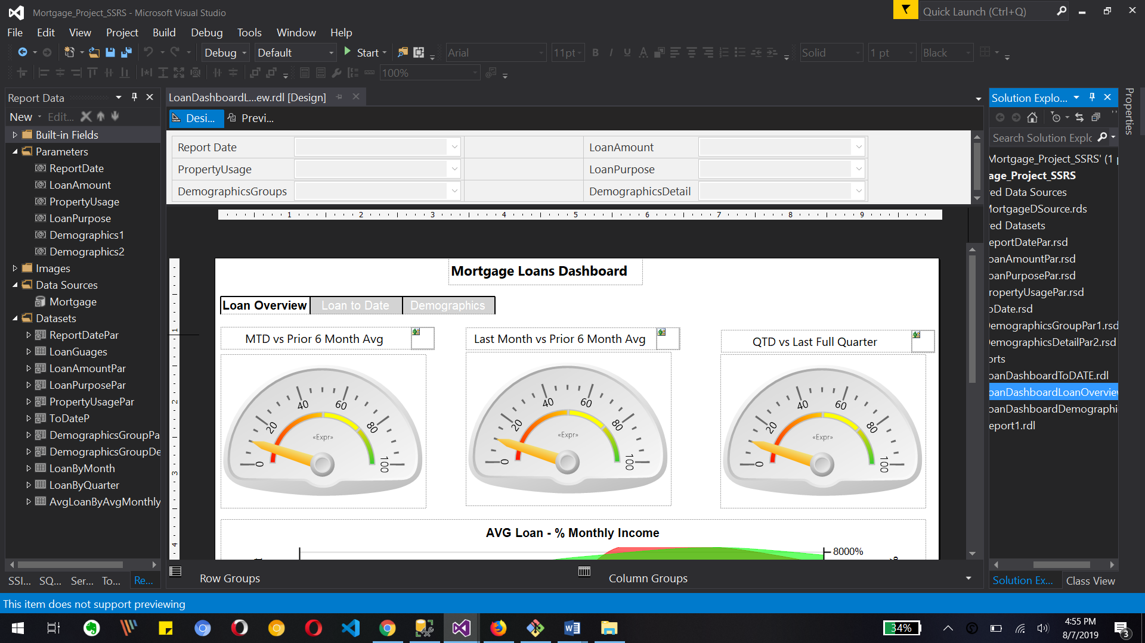

This is loan Overview part of mortgage loan dashboard. We can see MTD vs 6-month average, last month vs prior 6 month average and QTD vs last full quarter Guages.

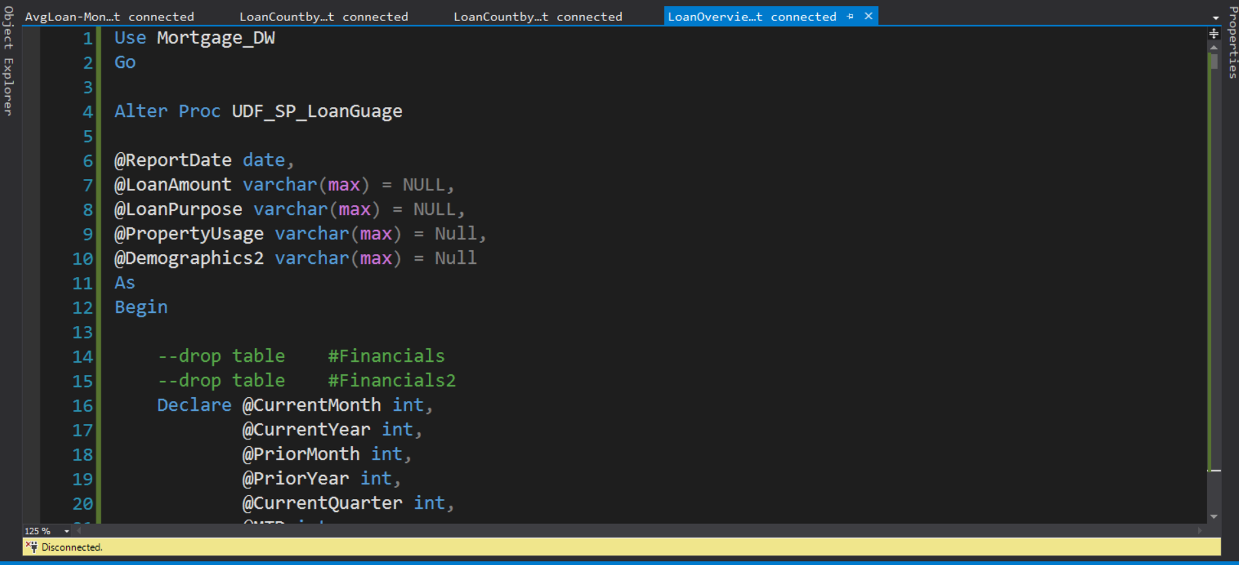

Now we create loangage stored procedure so we can use that data you know what gauge report

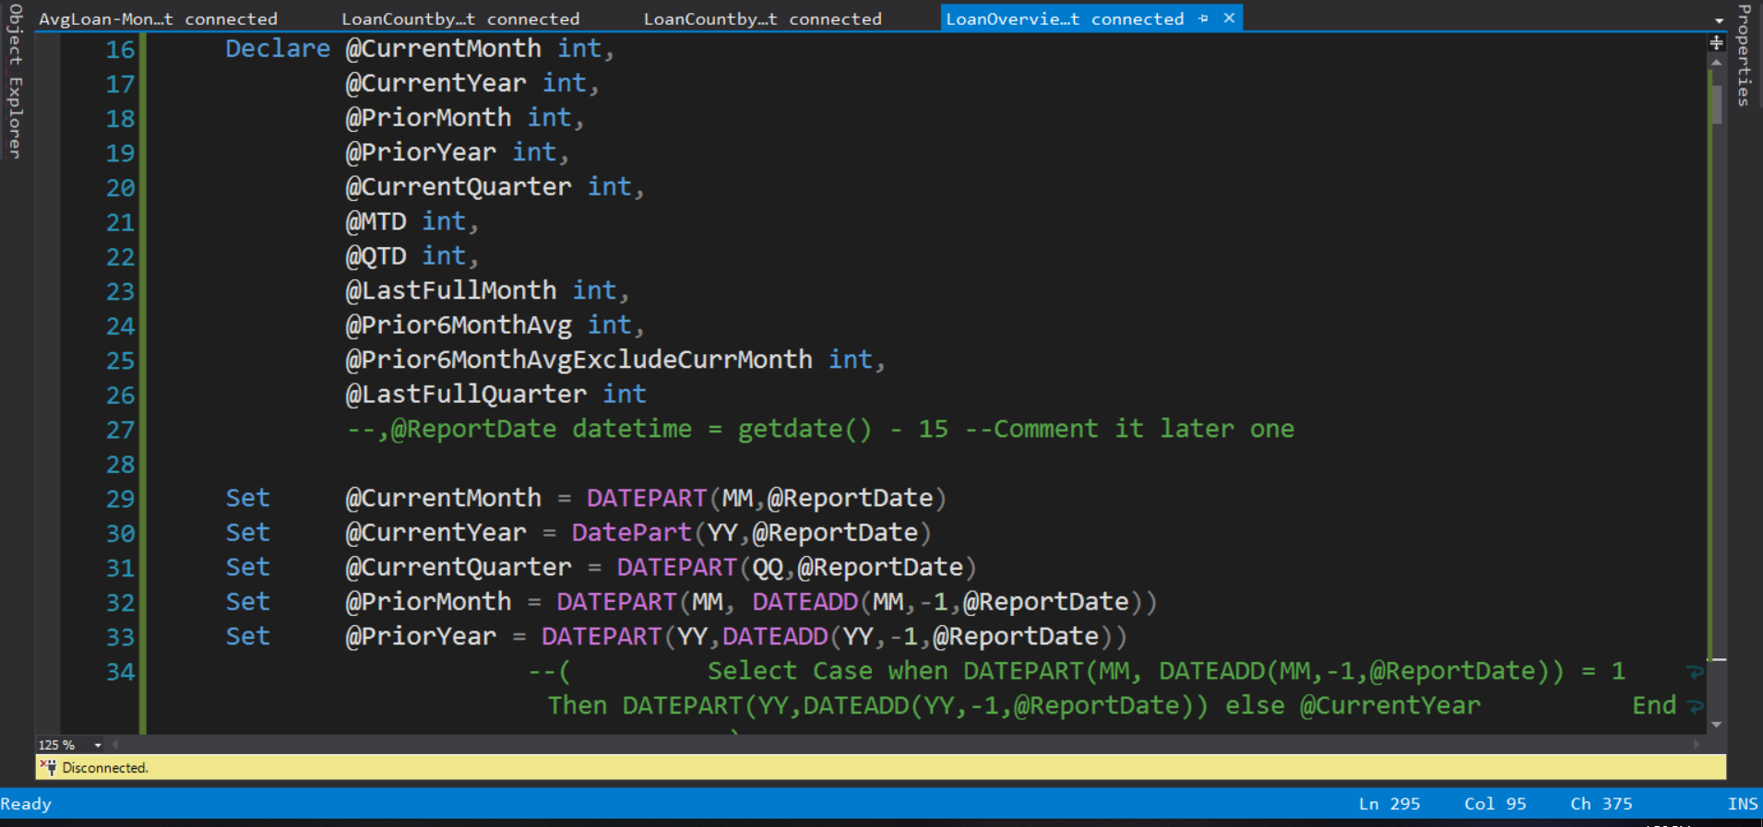

We need to declare some variables like current month, current year, current quarter, last full month, prior six month average and we need to use datepart function to get those value

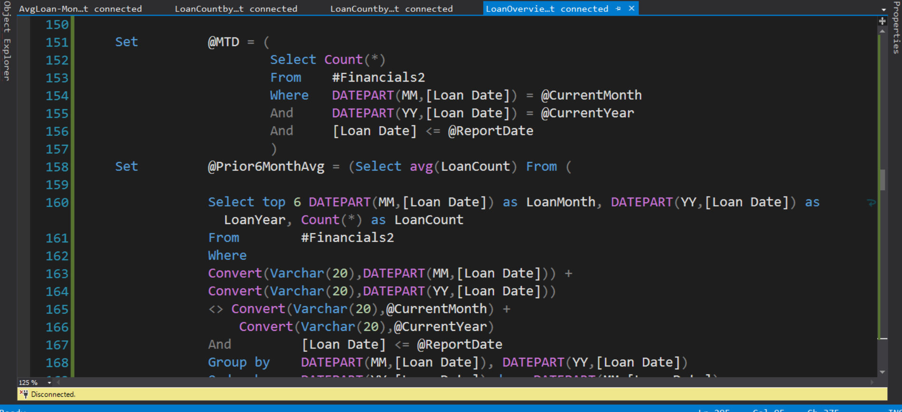

Now he said MTD variable where we use date part function. Also set prior six month average by using Dead part function

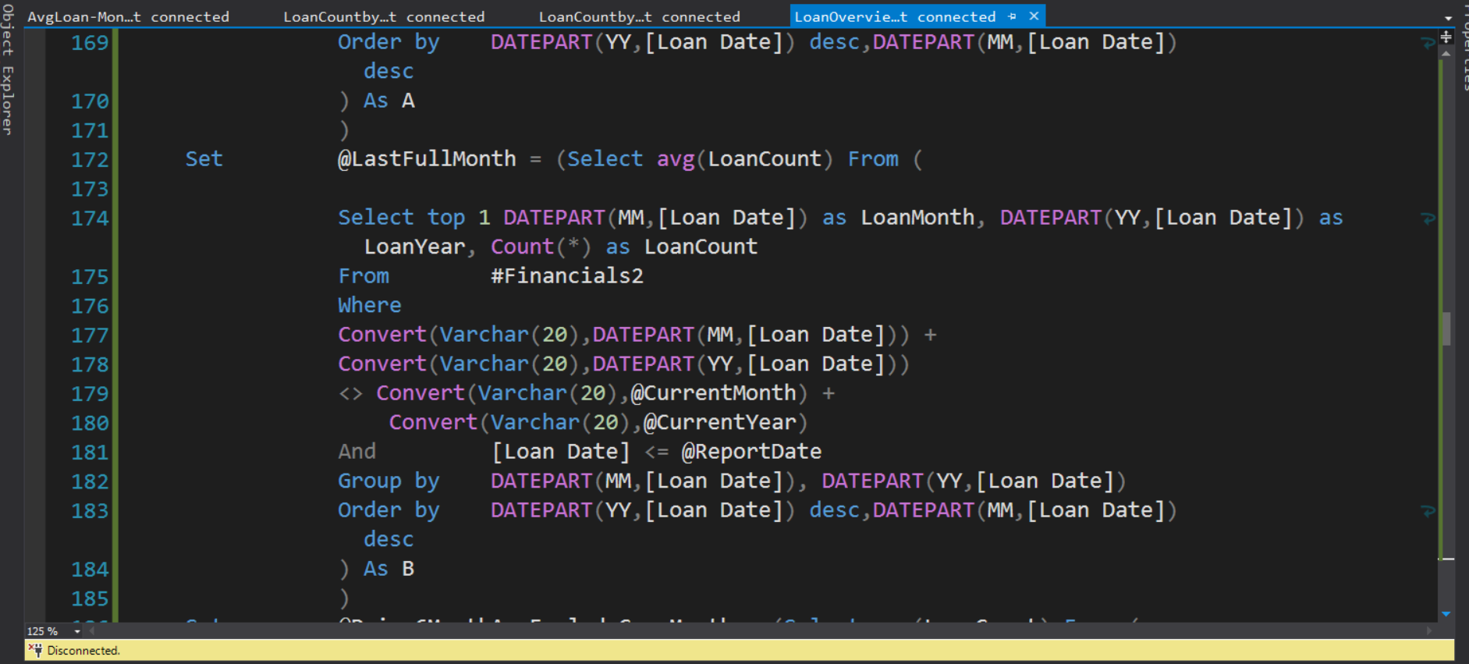

We got the last full month it's converting some data and also getting one month and loan year

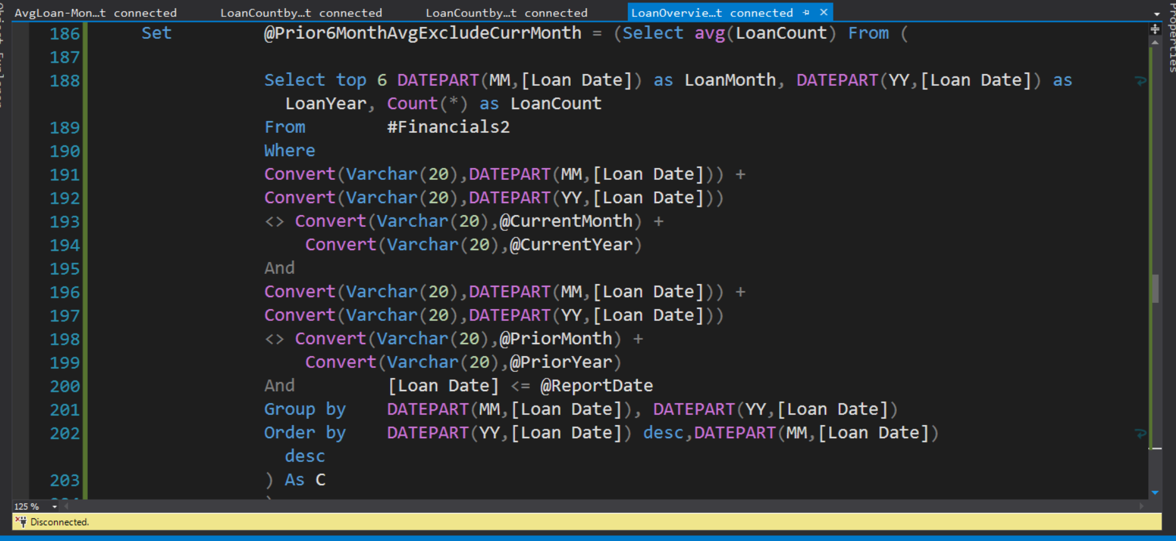

Also reset proud 6-month average exclude current month variable with comparing loan date by month and year

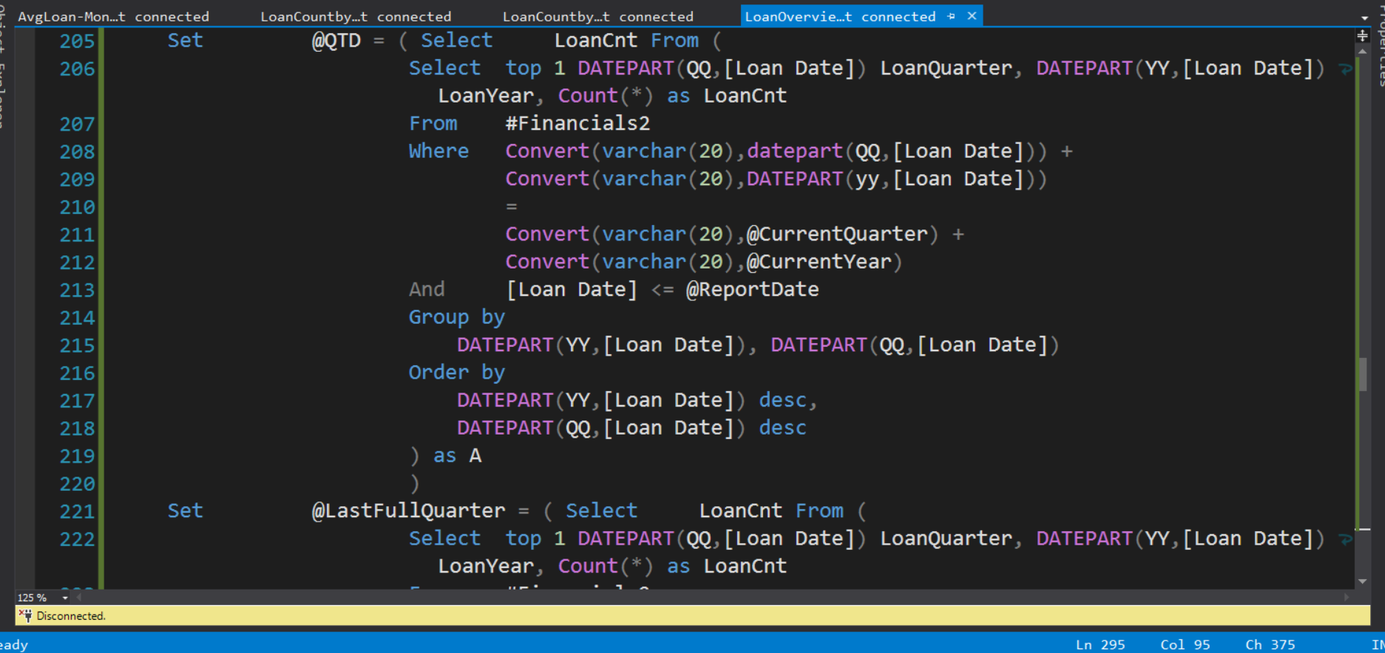

Reset @qtd variable as per image

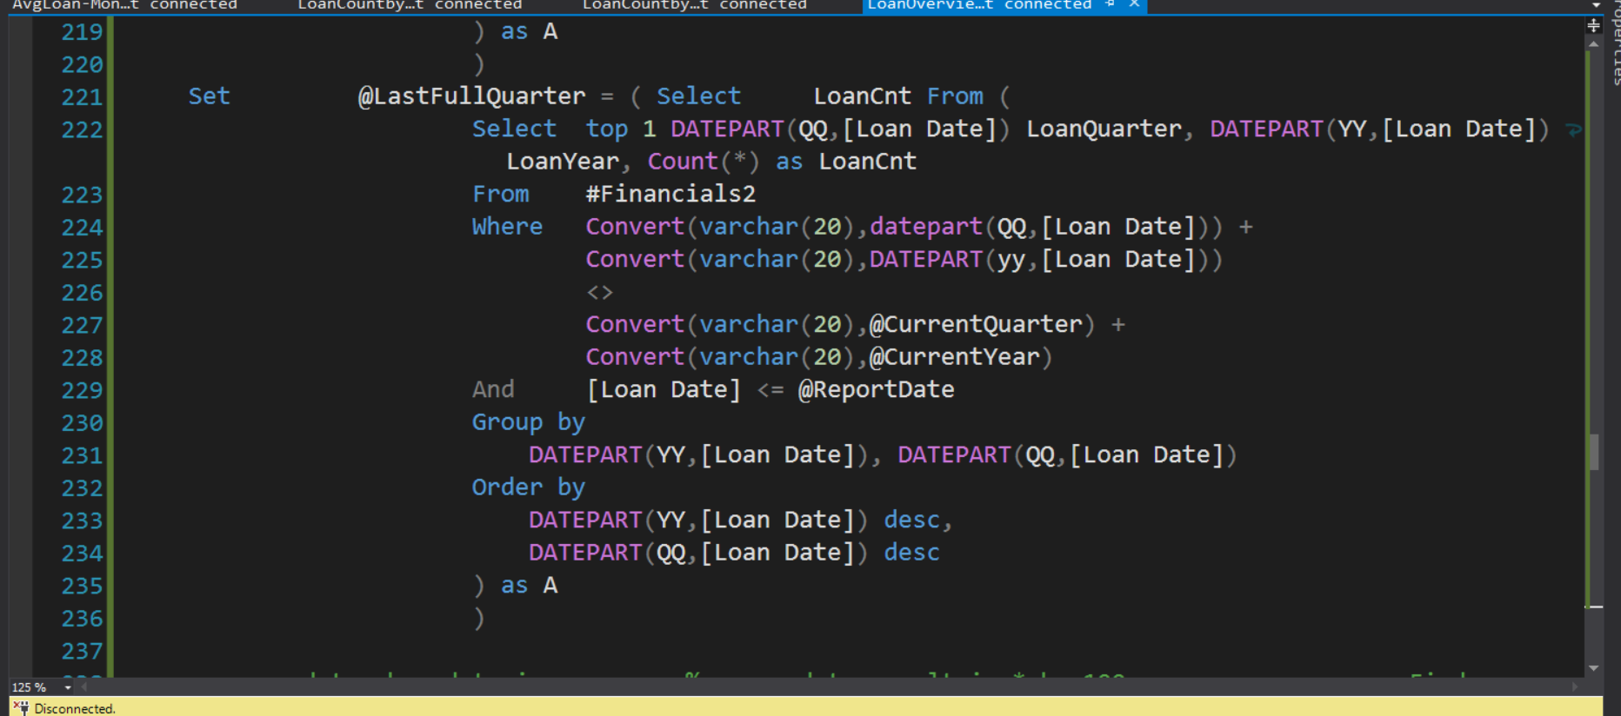

We are going to set last full quarter variable with datepart function for Quarter of year.

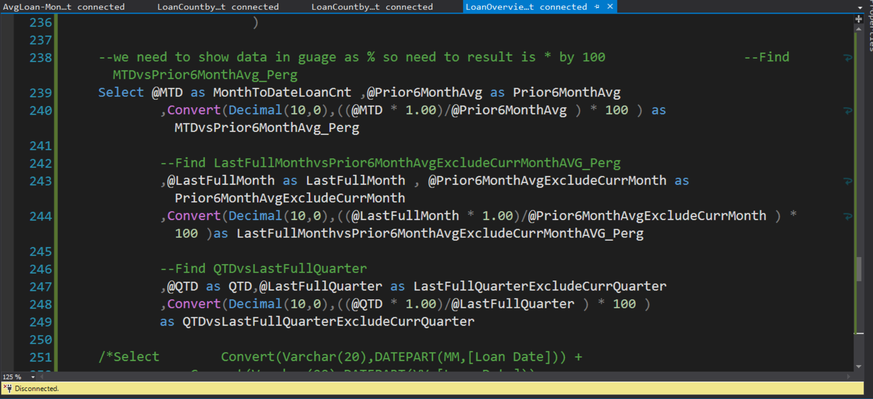

Now we set month to date variable and we will find the average with last full month and prior 6-month average exclude current month

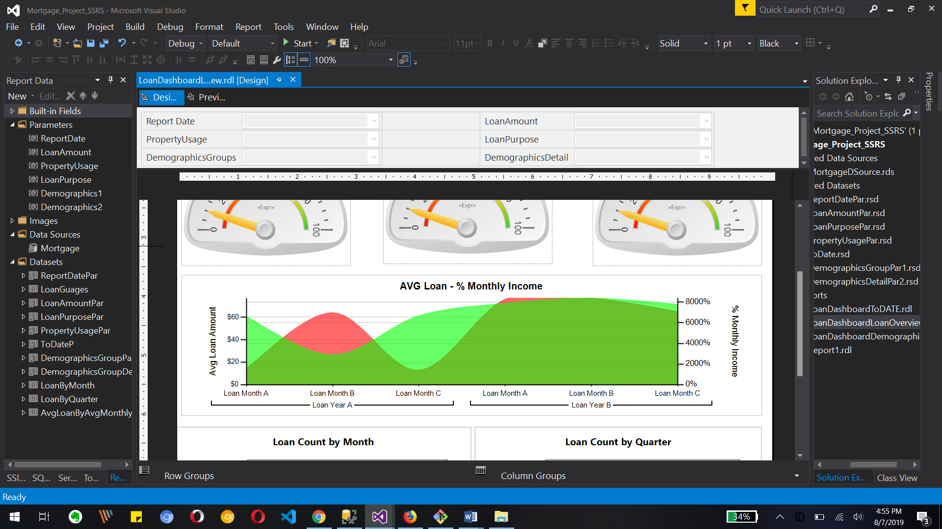

this is area map where we have average lawn by percentage of monthly income

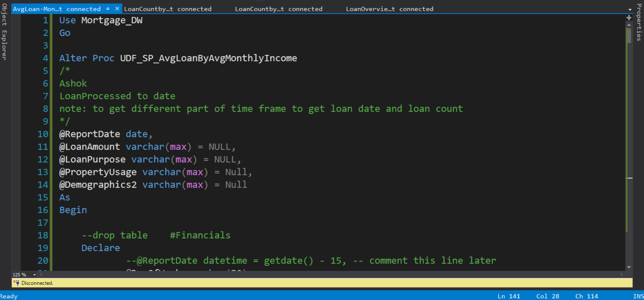

 now we will create average lawn by average monthly income stored procedure or meters

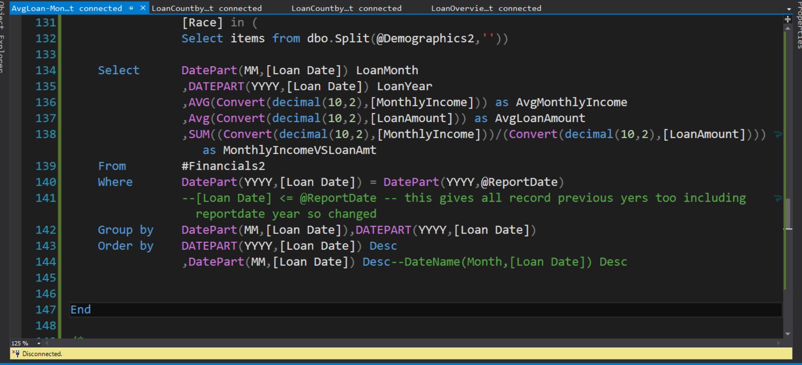

Beeville get lawn month-long your average monthly income average loan amount and we get the sum of monthly income by loan amount and store in financial temporary table

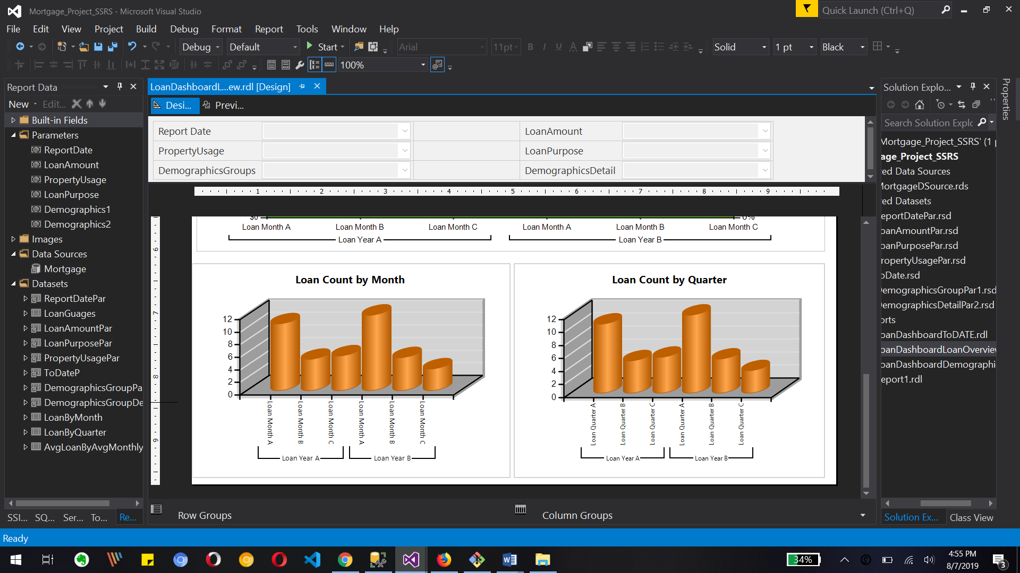

Soon image so was that lawn count by month report and Lawn count by quarter report

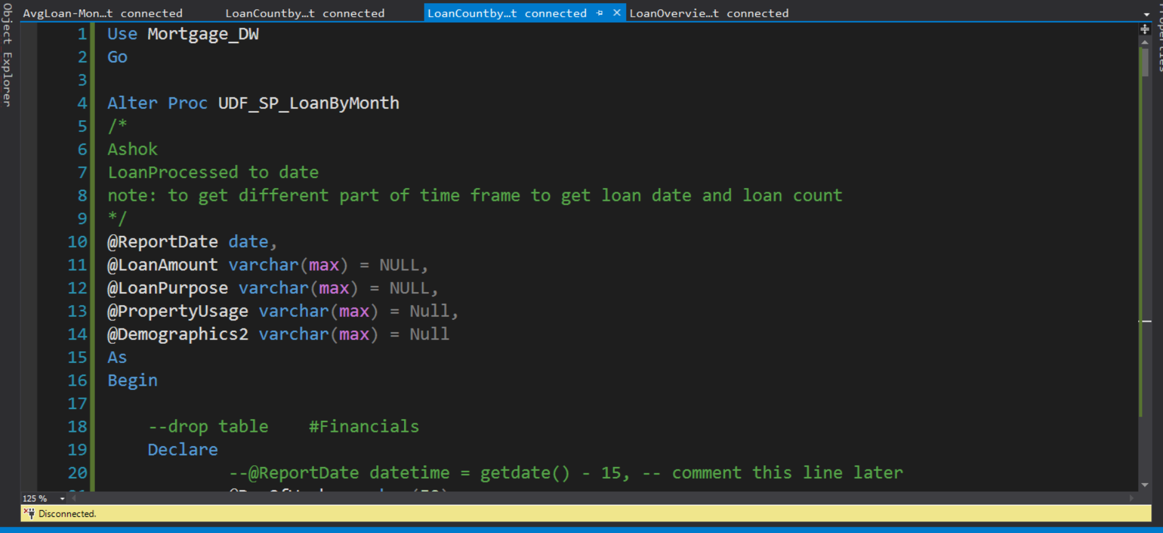

This stored procedure is for loan by monthly report

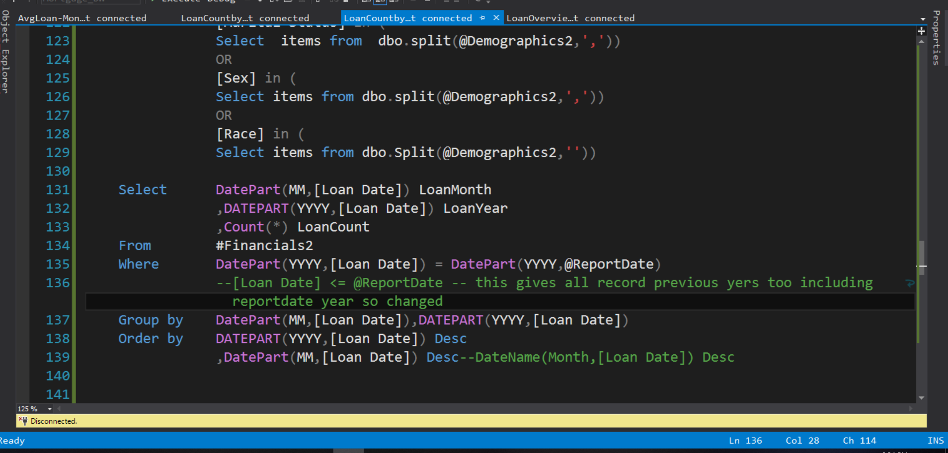

For loan by month report we need a loan month, loan year and Lawn count so we can use those data into our bar chart in report.

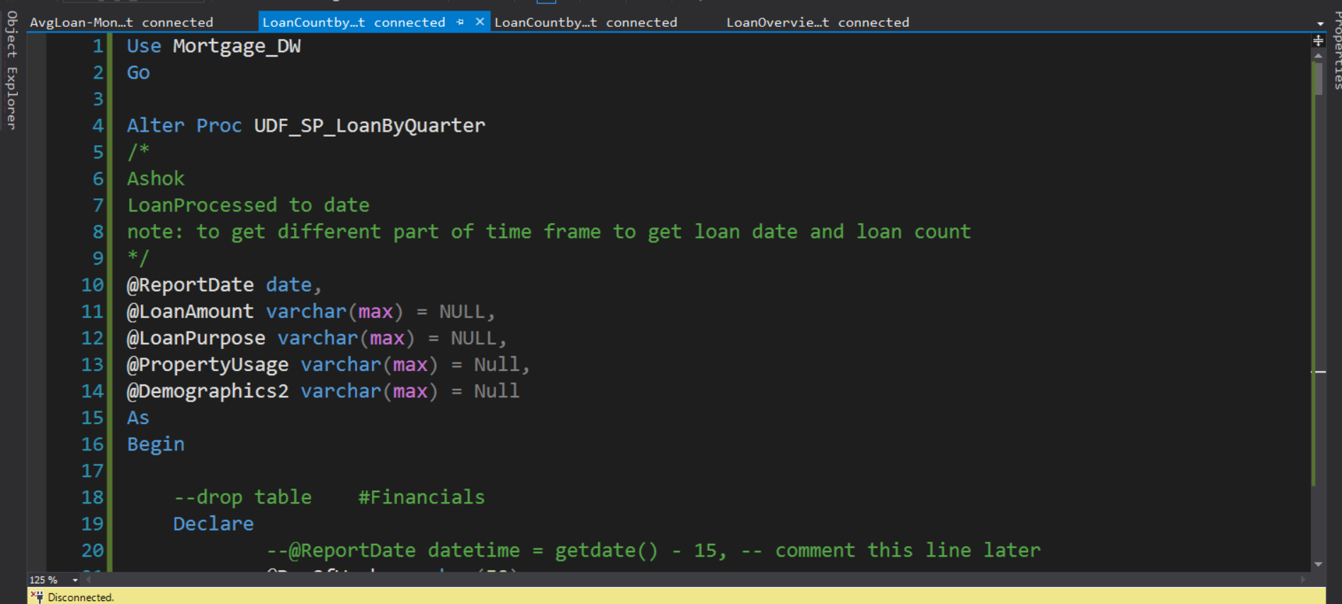

Now this is a loan by quarter stored procedure where we use that data for a our loan by quarter report

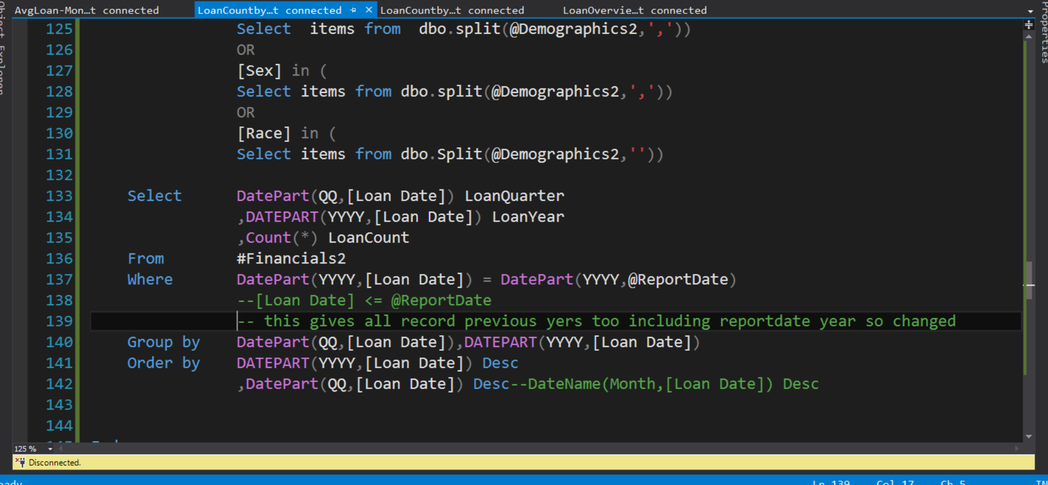

We need a loan quarter and longer and Lawn count based on a report date so we can use those three data for our lawn count by lawn quarter report

What to Submit:

1. IPBC Status Update : Mortgage Project Story 7 – 9

<https://app.colaberry.com/app/ipbc/videos?user=31221&category=14>

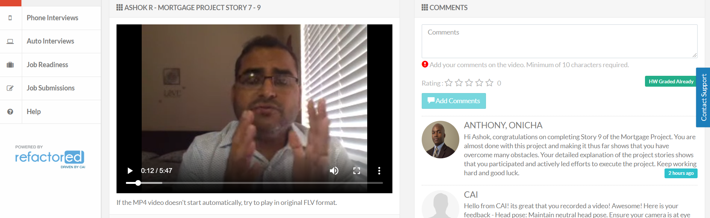

1. SQL BI Interview Questions: SSRS – What are the various type of reports you have developed

<https://app.colaberry.com/app/ipbc/videos?user=31221&category=40>

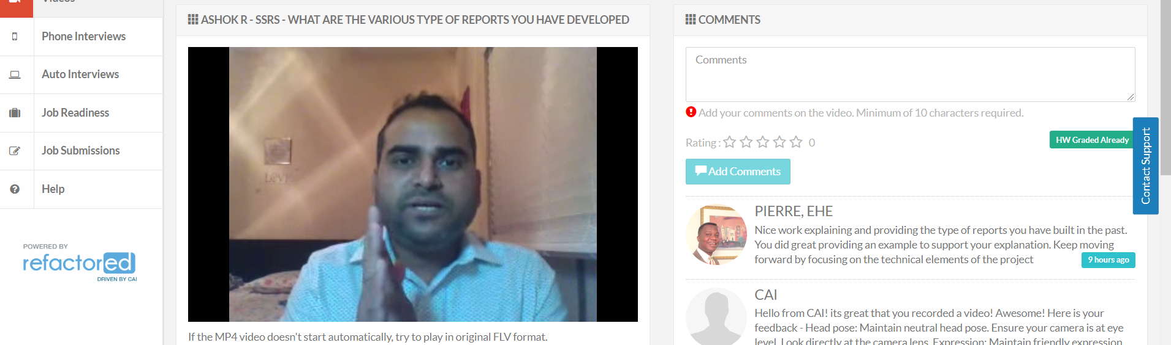

2. Watch, Comment &amp; take screenshots of your comments from 3 other videos on the same

topic (per question). Comments must be 20+ characters. Leave comments based on

presentation, delivery and/or technical details. Your critiques will help you be more

conscious of your own videos. (3 comment screenshots per Video Question)

* Mortgage Project Story 7 – 9

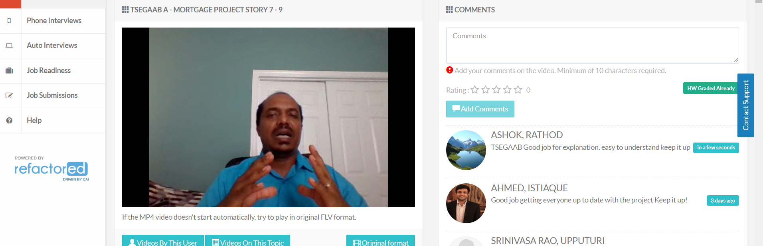

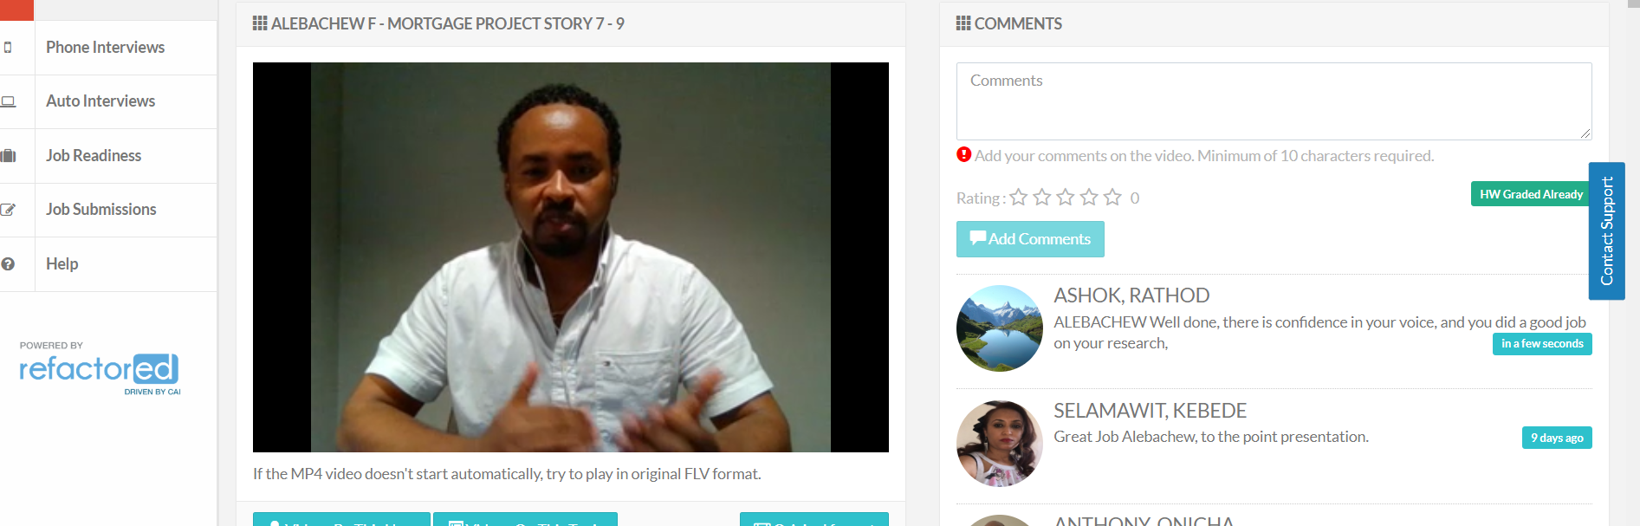

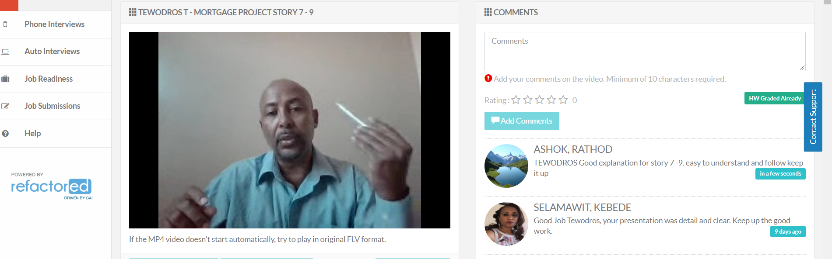

* What are the various type of reports you have developed

